**Homework 5: L, L, and more L**

**Quantum Mechanics II: PHYS 511**

**Gabriel M Steward**

**February 2022**

**Texts Referenced:**

**Modern Quantum Mechanics, Sakurai and Napolitano**

**Introduction to Quantum Mechanics, Griffiths and Schroeter**

**(Further references at the end)**

**Problem 1**

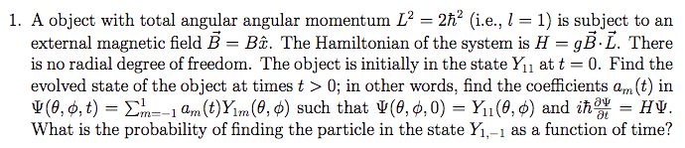

Let’s take this slowly to make sure we understand it. Our goal is ultimately to find the time evolved state of the wavefunction Ψ. Ultimately, this will be accomplished by solving the differential equation



With the initial condition of the Y11 state at t=0. We are also told that the full wavefunction is a linear combination of the spherical harmonics where l=1 (and thus m= -1, 0, 1.) Substituting this in provides:

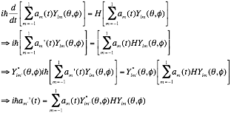

While we haven’t explicitly written it in yet, in our case l=1 no matter what.



At this point it is clear we can solve this equation for m’=-1, 0, and 1. However, perhaps there is still a way to simplify in this general form first? Substitute in our given Hamiltonian:

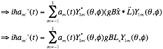

That dot product simplified things considerably, as now we can pull the constants g and B out, leaving only the operator Lx which, as it is acting on a spherical harmonic, it most definitely should have an eigenvalue for. The question is which one, as Lx was not directly defined in class. However, Lx can be written in terms of L+ and L-

L±=Lx±iLy

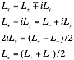

And the eigenvalues for L+ and L- are known. We can now rewrite our main relation as

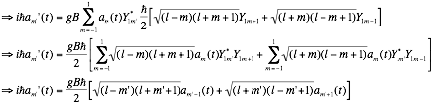

We remind ourselves that we are in the l=1 case and simplify.



We now write out the system for m’=-1, 0, and 1, knowing that if a harmonic were to ever reach m=2 or -2 when l=1, then it would reduce to simply zero. This gives us:

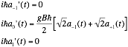

Note the two equals zero segments: those mean that those values are not dependant on time at all and are just constants. Which means we now solve for the a0’ in terms of them:

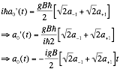

We still don’t know a lot of specifics, but we can now at least formulate the entire function:



At t=0 we need Y11.  So…



As we have shown a-1 and a1 to be constants, there is only one way for this to be true: a1=1 and a-1=0. This we can substitute back into our original equation and get:

|  |
| --- |
|  |

**Problem 2**

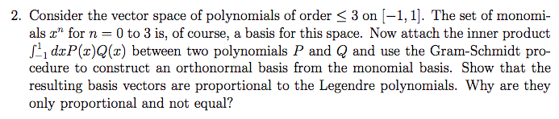

Written out, the monomials are 1, x, x2, and x3.

If the inner product is defined as then we know how to normalize, which in the case for 1 is just:



Which is sensible, as normalization would have been “1” if we had the bounds over a region of length 1.

Then we move onto the second “basis vector” x and seek to force it to be parallel to 1. This is represented as so:



Which we then normalize in the same way as the first one.



That’s two basis “vectors”. Repeat with x2 and x3 but using the general G-S form.

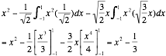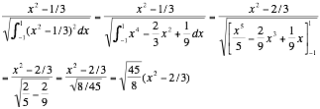

And we do it one last time. As always, the last “basis vector” is the most complicated.

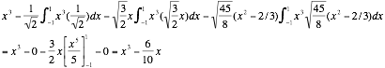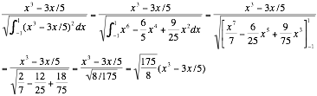

And so we now have our answers:

|  |
| --- |
|  |

For reference, the Legandre polynomials are 1, x, (3x2-1)/2, and (5x3-3x)/2. Each individual basis vector in our answer is proportional to one of these, but not exact. Why are they not exact? Well, because we “normalized” them according to the way the inner product was defined, which rather quickly led to the basis vector 1 not being normalized. There no doubt is a way to define the inner product to produce the actual Legandre polynomials.

Our answers can be thought of as the “unit vectors” for not only polynomial space, but also the Legandre polynomials: each unit vector is just a constant away from being one of the actual polynomials.

**Problem 3**

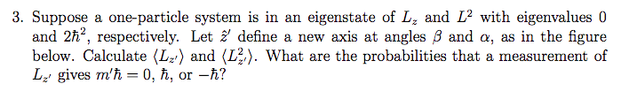

Helpful diagram included below.

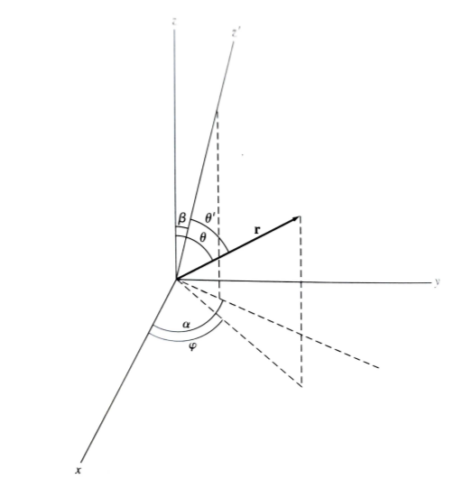

First of all L2 is ultimately directionless, so it remains the same no matter what we do to the coordinate axes. While it seems at first that we cannot assume the eigenstate is a spherical harmonic, we actually can, as evidenced by the fact that the problem asks for an m-value in the last part, which would require it be so. Therefore, we ask ourselves, what spherical harmonic is this?

Since Lz = -iћ(∂/∂φ) we do know that there is no φ dependence as the eigenvalue is zero. We also know that LzY = mћY, so for this spherical harmonic m=0.

Turning to L2 now, We know it follows L2Y=l(l+1)ћ2Y, which means l=1.

Thus, our spherical harmonic is Ylm=Y10. Which happens to be



Which, as expected, has no dependence on φ whatsoever. Unfortunately Lz’ will almost certainly have some θ dependence as everything’s been tilted slightly. How much, though, is the question?

Now we want to find the expectation values, which would be found via



Which depend, almost entirely, on us constructing a representation for Lz’. To fully accomplish this, we’ll need to come up with a coordinate transformation for the L-vector.



The Lx,Ly, and Lz operators are attained by substituting the unit vectors with the following.



So, if we could just find the x’, y’, and z’ unit vectors, we’d be great. How is another question entirely—how about we go with the 3D rotation matrix? We found it on Wikipedia [1]:

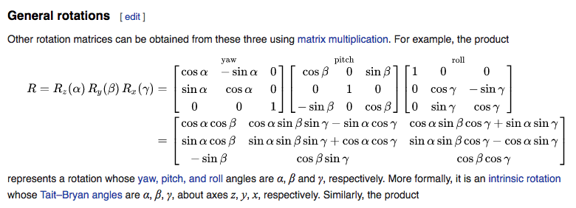

The angles even match our figure above. Every transformation of the z axis to z’ can be represented by two angles: α and β. The first is around the z axis, and the second can be interchangeably around the y or x, but in the above matrix it is y, so we shall define it as such. Since we can reach any position of z’ with just two adjustment angles, we can set γ to 0 for mathematical ease, producing the 3D rotation matrix of:



Let the Cartesian unit vectors be (1,0,0) (0,1,0) and (0,0,1) and then run them through this matrix to get new vectors. The results are:



One notices that the y-direction has no adjustment in its z-coordinate. This is because the angle of rotation β is around it—so it remains on the same plane as the original y-axis. Given two angles α and β, all the rotation accomplishes is fixing one axis—in this case, z. x and y could still be arranged at any angle relative to each other and it would be consistent with our problem statement. (This is what the third angle would have provided). For our problem, however, it does not matter what phase angle the x and y axes are at—the z unit vector still points the same direction regardless, so any valid arrangement of x and y will do.

The trick is now defining the x,y,z unit vectors in terms of the x’,y’,z’ unit vectors. It’s easy to do this in reverse:



Algebraic manipulations do not provide an evident answer. Wolfram Alpha [2], however, provided this:



Which we can then substitute into our radial unit vectors and simplify. Note: *we only care about the z’ component*, so x and y will be ignored.

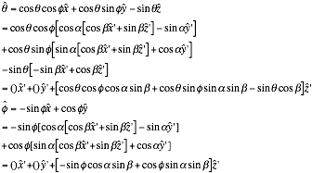

Now, at long last, we can define Lz’.

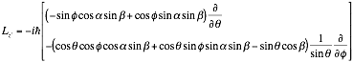

As expected, there is a θ-dependent component. However, the other component means nothing to us, as our spherical harmonic does not contain it. So our Lz’ might as well be



And we can square it to get the other operator we need.

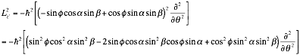

Now we can find the expectations via the aforementioned



Which we might as well just work out. Don’t forget the integration factor.

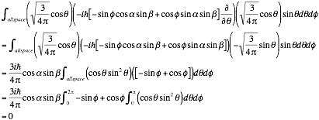

Which is what it *really needed to be* otherwise there would have been an imaginary number out there and *that* wouldn’t have been acceptable.

|  |
| --- |
| <Lz’> = 0 |

This seems odd at first, shouldn’t the expectation be something other than zero since we’re tilted away from our original point? However, mathematically speaking, it would have to be—the operator Lz’ (and Lz) have the imaginary number in them, and the spherical harmonics at m=0 (which is what we have) do not have imaginary components to cancel the imaginary number out. This implies that *all directions* have an expectation of zero, a perfect symmetry. Note how the terms that canceled came from the spherical functions themselves—it didn’t matter what our Lj was. (which implies we may not have needed to do all this work, but the Lz’2 remains). Furthermore, from a “physical” standpoint, every angular momentum vector is going to “center” on m=0 with equal potential to go ±m, thus it’ll even to zero.

Now the square isn’t going to behave quite as nice.

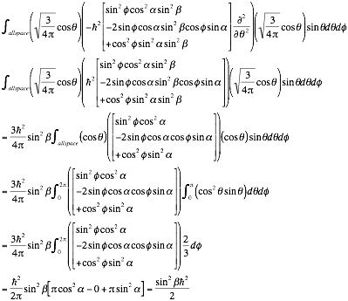

This is in terms of ћ2 and a fraction, which is promising, but it’s hard to tell if it’s realistic or not. One test, that of setting β to zero, does in fact make the expectation zero. Which is exactly what it should be as the spherical harmonic we’re using does *not* have φ dependence, which is good. So we say:

|  |
| --- |
|  |

However, the problem is not quite done yet… we need to find some probabilities. In general, the probability of measuring something in an eigenstate with a particular eigenvalue is:



Where α is the eigenfunction before measurement (Y10 in this case) and a’ is the complex conjugate of the eigenfunction with the specific eigenvalue we’re looking for. Which we don’t actually know since Lz’Y10≠0. In fact what it does equal doesn’t make much sense. However, we can solve for the wavefunctions that Lz’ would respond to—while this would be definitely annoying, we are firmly within l=1 space, so these new functions should be linear combinations of Y10 Y11 and Y1-1.

It was at this point the study group posted a portion of Merzbacher [3] which pointed out another way to state the Lz’ that, while it did confirm what we already had, gave it in a potentially more useful form. ([3] is a text we don’t have.)



This will be a bit easier to find proper answers for. We need to construct functions that result in 0, -ћ, and +ћ. Since these functions should be linear combinations of the three spherical harmonics, we need to know what they produce here. The raising-lowering version will work best for that.

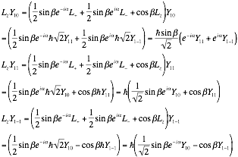

Some linear combination of these equal 0, -ћY10, and +ћY10. To find this, we should probably find what the other Y harmonics are in terms of Y10, if possible.

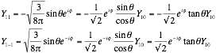

Note that they are negative complex conjugates of each other. With this, we can write all the combinations of harmonics in Lz’ as:

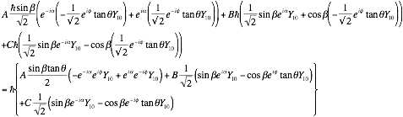

If we take the ћ off, we’re looking just for solutions of 1, 0, and -1. There may be more than one, for our purposes it doesn’t matter if there is or not, we just need one of each. (Actually, by symmetry, it might be possible to get away with just 1—the 0 case, since +m and –m must be equal because of our expectation value calculation).

Looking for 0 first, but the nontrivial solution, with A, B, C of each harmonic.

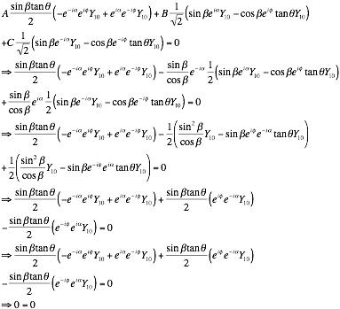

Which produces (non-normalized)



For the zero case. Since the harmonics themselves are already normalized, normalization is easier—but it is *not* as simple as treating the coefficients as vectors. Let’s see what this integral gives us right now. Remember, orthogonality makes a lot of things zero.

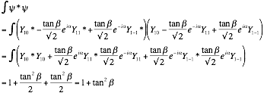

And so the normalized distribution is



Which we can also write just in terms of Y10 for calculation purposes.



Rather than trying to find the ћ cases, we will abuse symmetry—the remaining probability must be split evenly between the two of them, so we can just calculate the one.

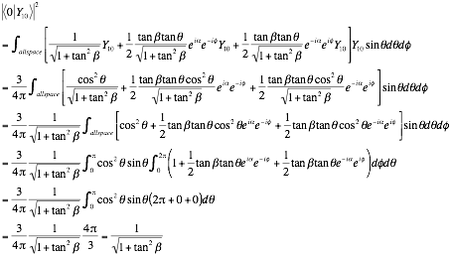

This, simply put, is beautiful. A reasonable probability that goes to 1 and β=0 and 0 at β=π/2, the most sensible of patterns.

We aren’t quite done yet, we need the ±m values. But, as we discussed, they have symmetry and are equal probability, and will be besed on the probability of the 0 case. Just 1- it and you get…

|  |
| --- |
|  |

REFERENCES:

[1] 3-D rotation matrix <https://en.wikipedia.org/wiki/Rotation_matrix>

[2] Wolfram Alpha, systems of equations <https://www.wolframalpha.com/>

[3] Quantum Mechancis by Eugen Merzbacher.